**Task -1**

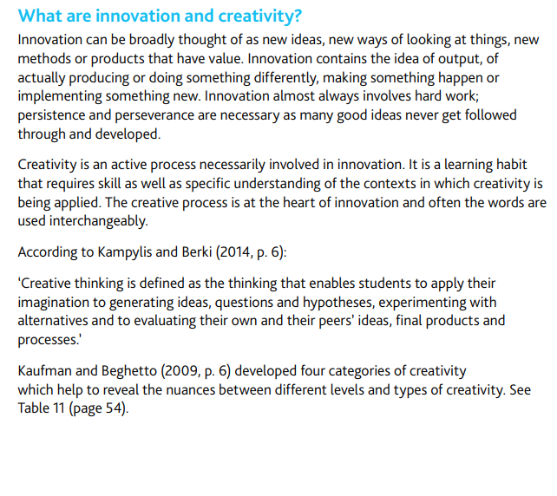

**Task -2**

**Task -3**

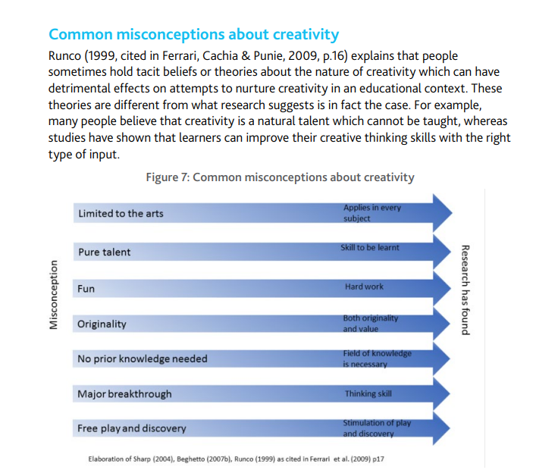

**Task-4**

**Task -5**

**Task -6**

